**­

2015-2016 Course Options

Bartlett Medical Academy

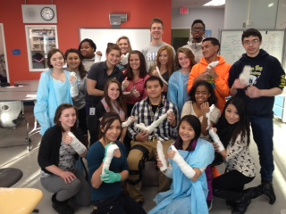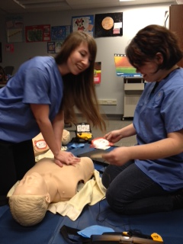

4 of the top 5 fastest growing careers are in the health field!

HEALTH OCCUPATIONS ESSENTIALS

Teacher: Ms. FitzGerald

Learn basic First Aid and CPR and get certified through the American Heart Association. This class is designed for anyone thinking about a career in the health care industry or wanting to learn more about their options in this field. This course is open to all students in grades 9-12

PHYSIOLOGY OF WELLNESS

Teacher: Ms. FitzGerald

This course is designed to introduce the students to the concepts and theories of wellness, sign/symptoms and management of diseases that affect each body system, body mass index, urinalysis, and exercise and its effects on the human body. This course is open to all students in grades 9-12

MEDICAL TERMINOLOGY\*

Teacher: Mrs. Stone

This one semester course is designed for students who want to understand medical language and terminology used by health care professionals. Students will gain an understanding of the rules of building medical terms from word origins and will learn correct definitions, and spelling for all of the body systems, diseases, common disorders, prescribed medications, and more. Whether a student is interested in learning more about the medical field or they want to acquire practical knowledge for future personal use, this course provides the foundation for understanding the language of medicine. This course also offers three UAA college credits.

Prerequisites: Biology or concurrent

ATHLETIC INJURY\*

Teacher: Mrs. Stone

If you love athletics or want to be a sports trainer/physical therapist this course is for you. Students will learn how to prevent, evaluate, treat and rehab athletic injuries, including wrapping/taping/bandaging techniques for athletes.

Prerequisites: Passed Biology, Anatomy recommended

INTRO TO PHARMACY\*

Teacher: Ms. FitzGerald

No matter where your interest lies in the health industry, everyone is part of a team. The pharmacist and pharmacy technician play an important role in determining medication needs of patients. Learn about common medications and how they work in the body along with gaining hands on pharmacy skills.

Prerequisites: Biology, Algebra and 11-12 gr.

\* UAA Tech Prep Credit Available